Caves Beach Photoshoot

January 25th 2023

Location, please meet in front of the clubhouse at 6pm on Wednesday 25th January.
We will investigate some photographic techniques when capturing images in and around the Caves Beach area.
Please work with at least 1 other person and be aware of possible dangers in this area
eg Tidal and wave actions, slippery, wet or algae covered surfaces, falling rocks, cliff edges, limited headroom in caves, just to name a few.
ALWAYS BE AWARE OF YOUR SURROUNDINGS

Some suggested techniques to try.
- Capturing motion blur of the water and waves Try shutter speeds of 1/10 to 1 sec this will give some definition, above 1 sec a milky effect will be achieved. This will also depend on how fast the water is moving in the first place. Look for rockpools and anywhere there is wave or foam action in or out. Use a tripod for slow shutters.

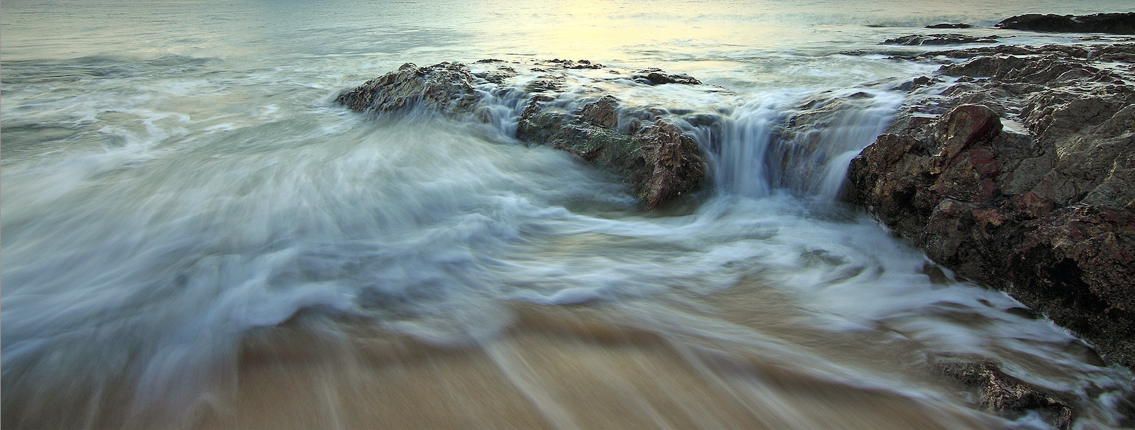

- Panning motion blur of the entire seascape Try hand held for starters and then progress to a tripod for best results. Lens choice 70 to 200mm rather than wide angle. Try shutter speeds of 1/10 to 1sec, Low ISO and small apertures. Pan in the direction of breaking waves.
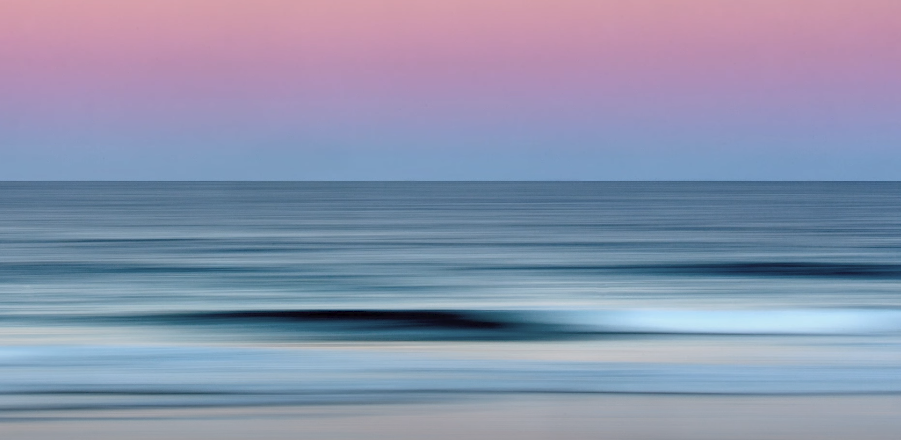

Enjoy the afternoon, Low tide is at approx 6.30pm and sunset at 8.01pm.
Golden hour – 7.27pm to 8.18pm: Blue hour – 8.18pm to 8.29pm

Greg Carruthers

