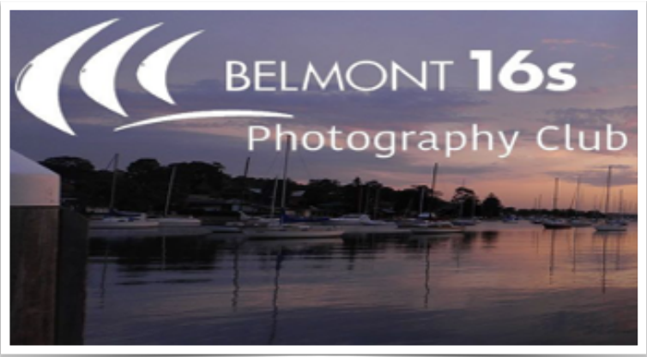
Welcome to our July issue of Skiffy – Dennis Archibald
We had a good night at our June club meeting. Congratulations to all those who received awards from our 2021 competitions and thanks to our committee members who organised the refreshments for the night, and to all those who helped to make the night successful.

In addition to the 2021 award presentations, we kicked off the 2022 print competitions and a special thanks to Brad LeBroque who was our judge for the night

Our next club night will be at the Valentine Bowling Club at 7.00pm on Wednesday 13th July. In addition to the judging of print entries Sean Sylvester will start the evening with a short presentation on Lightning Photography. You will find more information on Sean’s talk in this month’s edition of Skiffy.

Finally, can I urge members who are attending the club nights to join the Valentine Bowling Club (VBC) as social members. The club is allowing us to use their upstairs function room without charge for our meetings and they welcome any support that our club can provide in return.

Judging and Club Competitions – Di Schofield
Please note that digital and print competition entries for July must be entered and uploaded by 11.00pm on Sunday 10th July.
Print and digital competitions in July are for:
- Colour prints
- Nature prints
- Open Colour digital
- Nature digital
- Set Subject digital – Photo Travel
Please refer to the club competition rules for number of entries and print sizes allowed for each grade.
Our print judge for July is Barry Collier.
Our EDI judges for June are:
- Open Colour – Jennifer Carrigan
- Nature – Chris Prior
- Set Subject – Photo Travel – Roy Killen

Photo Travel Definition
A Photo Travel image expresses the characteristic features or culture of a land as they are found naturally. There are no geographic limitations. Images from events or activities arranged specifically for photography, or of subjects directed or hired for photography are not permitted. Close up pictures of people or objects must include features that provide information about the location. Techniques that add, relocate, replace or remove any element of the original image, except by cropping, are not permitted. The only allowable adjustments are removal of dust or digital noise, restoration of the appearance of the original scene and complete conversion to greyscale monochrome. Other derivations, including infrared, are not permitted. All images must look natural.
For those who entered the June Mono digital competition you may be interested in the following comprehensive feedback from the judge, Jen Fawkes.
“Thank you for the invitation to judge for your club once again. It’s always nice to be invited back, and I enjoy the skill and variation in images that you regularly provide.
Firstly, a little about me (the boring part). I’m a member of Waverley Camera Club in Melbourne, where I am on the committee and provide the club’s education. I am a passionate amateur photographer with a love of street photography, monochrome, photojournalism, and travel (and at times do a little creative portraiture.) At times I do a bit of judging for both camera clubs and exhibitions.

I am also a member of PSA (the Photographic Society of America) where I am a coordinator for a course I wrote “Image Evaluation” and am an instructor for several other courses. I was recently successful in achieving my EPSA.

I love looking at the work in monochrome, but with so many programs and pre-sets, this genre is now
fraught with dangers. I hope I have been able to point out some of these in my comments. For me there are several features in monochrome that are worth thinking about:
- Subject choice. Not every subject will work in mono. Someone once told me that if the image works in colour, then leave it. If not, then try mono.
- Converting to monochrome changes the story of the image. What might be an image of a building, becomes an image about textures, contrast, and tone. They become different images.
- There are several ways to convert an image to monochrome, and none is fool-proof. It’s worth learning several different ways, so that if it doesn’t work using one method, you have other options.
- Carefully using pre-sets (such as Nik Silver Efex). Learn to control the amount of brightness, contrast and structure to create an image you like, rather than one that is pre-set for you.
- Be careful about over processing – too much sharpness will create white halos.

Lastly, I though it is worthwhile to let you know how I assessed your images, and this was different for each grade:
B Grade:

Since I am led to believe this is the new or emerging photographer group, for these images I am looking for camera competence. The subject choice, or originality is less important as the skills of choosing the right depth of field, having sharpness where you need it, or learning about composition to create stronger images. The key message I give this group is to learn the art of observations, and to LOOK at your scene rather than to react to how the scene makes you feel.
A Grade:
I’m expecting a little more from this group as I assume you have mastered the basic skills and are starting to experiment. In this level of skill, you need to be working on seeking good light, thinking about perspective, angles, and especially composition. Also, in this group you can start to think about how you make your images more original or unique, so that your images stand out from all the others.
Advanced Division:
I’m probably the hardest of all on this group, and I’m starting to expect to see images that I believe will do well in higher levels of competition. At this level, everyone has competent technical skills, and the artistic skills will make the difference between an ordinary image and an award-winning image. This is the chance to think outside the box and be creative, even with the most ordinary subjects. It won’t always work, but if you don’t try, you will never know.
Thank you again for inviting me to be your judge. I have enjoyed looking at your images and I hope to meet up with you all someday.”
Jen Fawkes
EPSA, FAPS, SPSA.

CONGRATULATIONS TO HELEN WALKER

Helen has recently been awarded a PSA Bronze medal (human interest academy) and 24 acceptances in the PSA Annual Exhibition Competition 2022 (Digital). Well done Helen.

A LEARNING OPPORTUNITY FOR CLUB MEMBERS – Roy Killen

The Club Committee recently approved a program that will enable club members to improve their individual photographic skills and share their new knowledge with other club members. The program will operate as follows:

- Individual club members can join the Photographic Society of America (PSA) at a cost of approximately A$60 for one year.
- After joining PSA, they can undertake a range of online courses at no extra cost. There is a wide variety of courses (see list below) to suit photographers at all levels. In addition, PSA members can take advantage of many other free member benefits (see list below).
- After completing a PSA course, the Belmont 16s member will be asked to present a Zoom or in-person tutorial/workshop to share their new knowledge with other club members.
- After presenting their tutorial/workshop the member will be entitled to a full refund of their one-year PSA membership fee. [The funds for this will come from the accumulated profits of the Lake Macquarie International Circuit that was run on behalf of the club.]

In all of the PSA courses, the student works one-on-one with an experienced instructor, progressing at a pace that suits their skills. The courses currently available are:
- Digital Photography – 6 lessons covering camera operation and basic approaches to photographing a range of subjects including portraits, architecture and still life.
- An Introduction to Photoshop – approximately 6 months.
- Portrait Photography – approximately 6 months.
- Still Life Photography – 5 lessons exploring all aspects of still life.
- Light Painting – approximately 3 months.
- Image Evaluation – a preparatory course for those considering (or already) judging - approximately 6 months.
- Creating Images for PSA Competitions and Exhibitions – an advanced 6 month course for those who want to produce competition-standard images.
- Photo Travel – an advanced PT course for those entering PT exhibitions approximately 2 months.
- Creating a PSA Portfolio – intensive preparation for submitting a PSA portfolio - approximately 3 months.
- History of Photography – approximately 4 months.

Roy Killen can provide you with more details about each course.
In addition to the online courses, the PSA membership fee entitles the member to:
- A monthly PSA Journal (in PDF format)
- A personal gallery on the PSA website
- Member discounts on various photography products
- A personal mentor
- An image evaluation service
- A Photo Travel advisory service
- Study groups
- Access to a library of webinars
- Competitions
- Access to the PSA photographic distinctions system and portfolio distinctions system.

If you would like to participate in this program, please contact Roy Killen who is coordinating the program (email: roykillen@mac.com). He will assist you to join PSA and enrol in the course of your choice. If you are already a PSA member, you can participate in the program by contacting Roy.

Lightning Photography – Sean Sylvester

Sean Sylvester is a photographer of 35 years and an Advanced Grade member of our club. He'll be doing a presentation on lightning photography at our July club night. He has photographed lightning in all types of gloomy weather and has won many awards within our club with his lightning images. He'll be going through the aspects and his process in how to obtain the photographs he takes along with some of the risks. He's a great presenter, you don't want to miss this!!
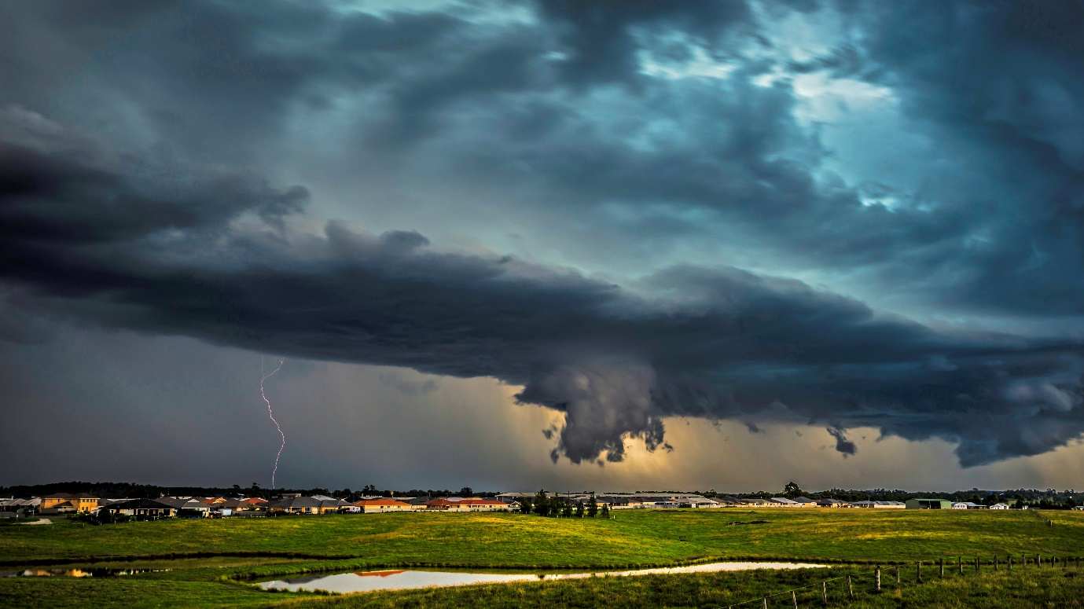

JULY PRESENTATIONS, WORKSHOPS AND RAW IMAGE CHALLENGE – Greg Carruthers

The following ZOOM presentations will be held in July:
- Wednesday 20th July, Greg will be running an introduction to Lightroom Classic with an emphasis on understanding the basics. The presentation will target beginner users. There should be plenty of time to ask questions or sort out issues.

- Wednesday 27th July Michael Snedic, a photography tour guide will be presenting “Wildlife photography”. You can find out more about Michael’s images and expeditions on his website https://wildnaturephotoexpeditions.com/
Raw image challenge continues for July with an image available for download in week 1. Your edited image must be uploaded by 31st July.
I have colour calibration Spyder for calibration of monitors along with matt boards at $2 each.

PSA INTERCLUB COMPETITIONS – RESULTS FROM ROUND 3 and CONSOLIDATED

OPEN SECTION

Belmont 16s competed in Group C (a total of 25 clubs) and finished in FIRST place after the three rounds. This great result will see us promoted to Group B for the next competition.
In Round 3, Chris Prior received a HM for his image “Portico walk”.

CREATIVE SECTION

Belmont 16s competed in Group B (a total of 20 clubs) and finished in EIGHTH place after the three rounds.
In Round 3, Peter Stanley received a HM for his image “Bat out of Hell” and Carol McGrath received a HM for her image “The crying sky”.

NATURE SECTION

Belmont 16s competed in Group A (a total of 23 clubs) and finished in TWELFTH place after the three rounds.

We did not receive any awards in Round 3.

PHOTO TRAVEL

Belmont 16s competed in Group A (a total of 24 clubs) and finished in THIRTEENTH place after the three rounds.

We did not receive any awards in Round 3.

PHOTOJOURNALISM

Belmont 16s competed in Group A (a total of 19 clubs) and finished in FIFTH place after the three rounds.
In Round 3, Chris Prior received a HM for his image “Mountain to climb”.

If you go to this page of the PSA website https://resources.psa-photo.org/index.php?2021-22-season you can review the award-winning images in all categories.

Entries for Round 1 of the next series of PSA Interclub competitions will close on 15th October. Entries will open on the club website soon.

If you have any questions about the PSA Interclub competitions, please email roykillen@mac.com.

NORTHERN PHOTOGRAPHIC FEDERATION (NPF) WEEKEND

This year the NPF event will be held at the Kurri Kurri Bowling Club on the weekend of the 27th – 28 August at the Kurri Kurri Bowling Club

The organising committee will meet soon to finalise the agenda. Admission price not yet determined but it is hoped to be less than $50 for the 2 days.

There will be 3 rooms:
- Exhibition
- Trade
- Portrait studio

Attending:
- David Oliver
- Claire Oliver
- Tim Bauer
- Selena – Sun Studios
- Doug Coleman

Peter Eastway may be attending

Olympus will be donating a camera to give away – an underwater tough shoot

Trade Reps attending:
- Momento Pro
- CK Kennedy
- Les Porter
- Nikon
- Canon?
- Olympus?

A print competition will be held.

Castle Hill and Port Macquarie have asked to join the NPF

Final agenda will come out at the beginning of August.

Instagram

The club runs an Instagram page. Each month our competition award winners will be contacted to request if they would like their image placed on the club’s Instagram page. This allows the Club to promote the competitions and the Club to hopefully attract new members.

The decision to share an image on our Instagram page rests with the image owner. If you would like more information about Instagram, please contact committee member Carol McGrath via email at belmont16sphoto.insta@gmail.com

Buy, Swap and Sell with Julie Brooks

Email me a photo or two of your items, a brief description including the all-important technical specifications, your price and email address. In Julie’s absence please email bicton36@gmail.com

Judging Course Last Call

The 2022 club Judging Course is now confirmed for Saturday 13th and Sunday 14th August and will be held at the St Johns Ambulance Training facility at 1b Court Street, Adamstown. Start time is 8.45am on Saturday and the course will run to approximately 5.00pm on each day. There are tea/coffee facilities available for a gold coin donation and lunch will be taken at the nearby Gates Hotel. The fee is $20.00 pp for club members. Non club members will pay $40.00, with all fees going to the St. John Ambulance as a donation. There are still places available for club members so be quick as we will open attendance to other clubs soon. Contact Bill Chambers via email – batfish2@bigpond .net.au.
